Little St Michael’s – the Retreat House, 85-8 Chilkwell Street Glastonbury BA6 8DD

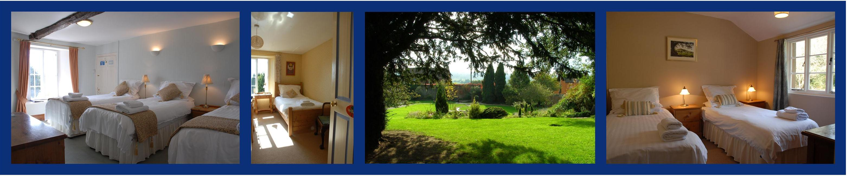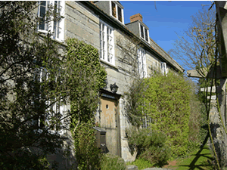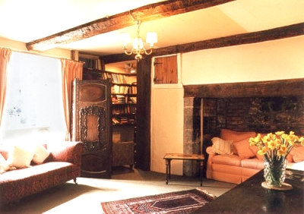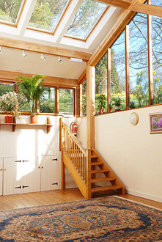

Weather permitting, we will hold one of the Holy Fire Master ignitions or Holy Love experiences by the sacred healing waters of the Chalice well. This is a place where, for millennia, people have come for healing and learning. It is the point where the pure water leaves the earth and meets the air for the first time. It is a place of healing, peace and joy.

All meals will be vegetarian/vegan and the house is kept free of internet, phone, and electronic devices. Rooms are single, twin, double and triple, all with shared facilities. Let us know if you have any special requirements. *“We do our best to hold this special place, keeping it clear, clean and filled with light and love”.*  The Housekeeping Team

The wonderful old retreat house of Little St Michael’s will be our home over the four days of the course. It was built in the 16th Century and has a lovely training room attached.

The class will start at 2pm on Friday 20 February and will end at 1pm on Monday 23 February.

There will be an opportunity afterwards to visit the sacred places in Glastonbury for those who wish to further explore the energies of this place.

The Michael and Mary ley lines meet and cross in King Arthur’s Court, an area of the Chalice Well Gardens. There is a quiet power in the Gardens. When the visitors have departed, the gardens can be more fully and deeply experienced.